Code based test 1

Question 1: books, reviews table

--create a table Books

create table Books

(Book_id int primary key,

Title varchar(20),

Author varchar(20),

ISBN bigint unique,

Published_date DateTime)

--insert values to the table

insert into books values

(1,'My First SQL Book','Mary Parker',981483029127,'2012-02-22 12:08:17'),

(2,'My Second SQL Book','John Mayer',857300923713,'1972-07-03 09:22:45'),

(3,'My Third DQL Book','Cary Flint',523120967812,'2015-10-18 14:05:44')

(Write a query to fetch the details of the books written by author whose name ends with er.)

select * from books

select book_id,title from books where author like '%er'

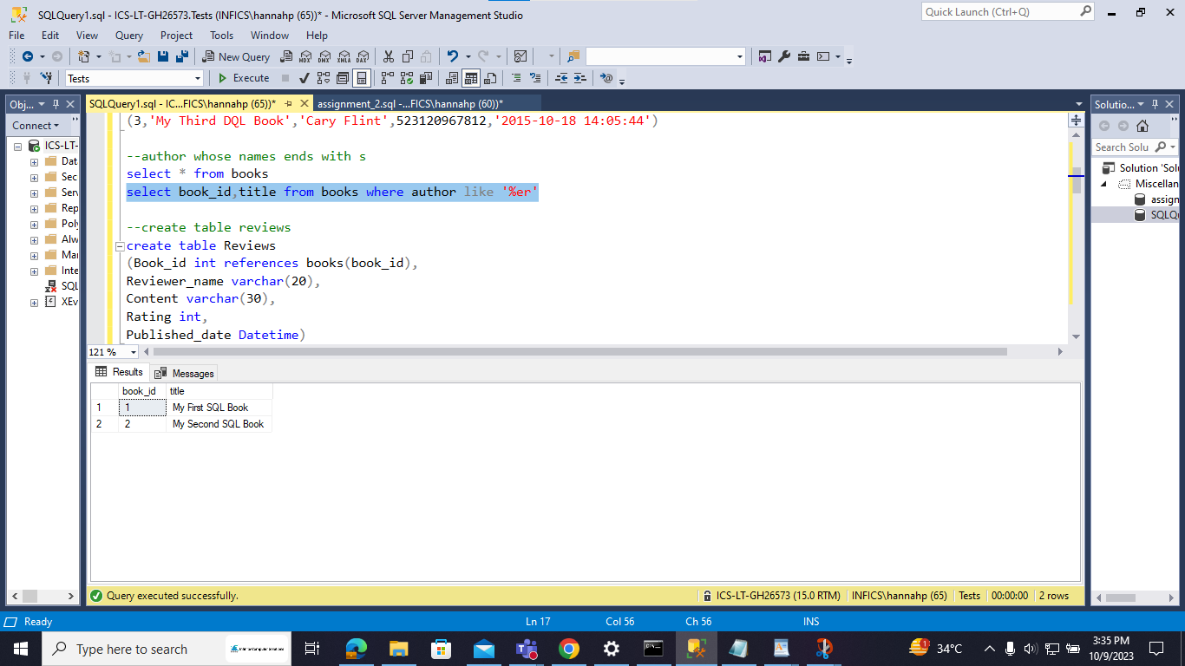

--create table reviews

create table Reviews

(Book_id int references books(book_id),

Reviewer_name varchar(20),

Content varchar(30),

Rating int,

Published_date Datetime)

--insert values to table reviews

insert into reviews values

(1,'John Smith','My first review',4,'2017-12-10 05:50:11.1'),

(2,'John Smith','My second review',5,'2017-10-13 15:05:12.6'),

(2,'Alice Walker','Another review',1,'2017-10-22 23:47:10')

(Display the Title ,Author and ReviewerName for all the books from the above table )

select * from reviews

select b.title,b.author,r.Reviewer_name from Books b, Reviews r

where b.book_id = r.book_id group by b.author,b.title,r.Reviewer_name

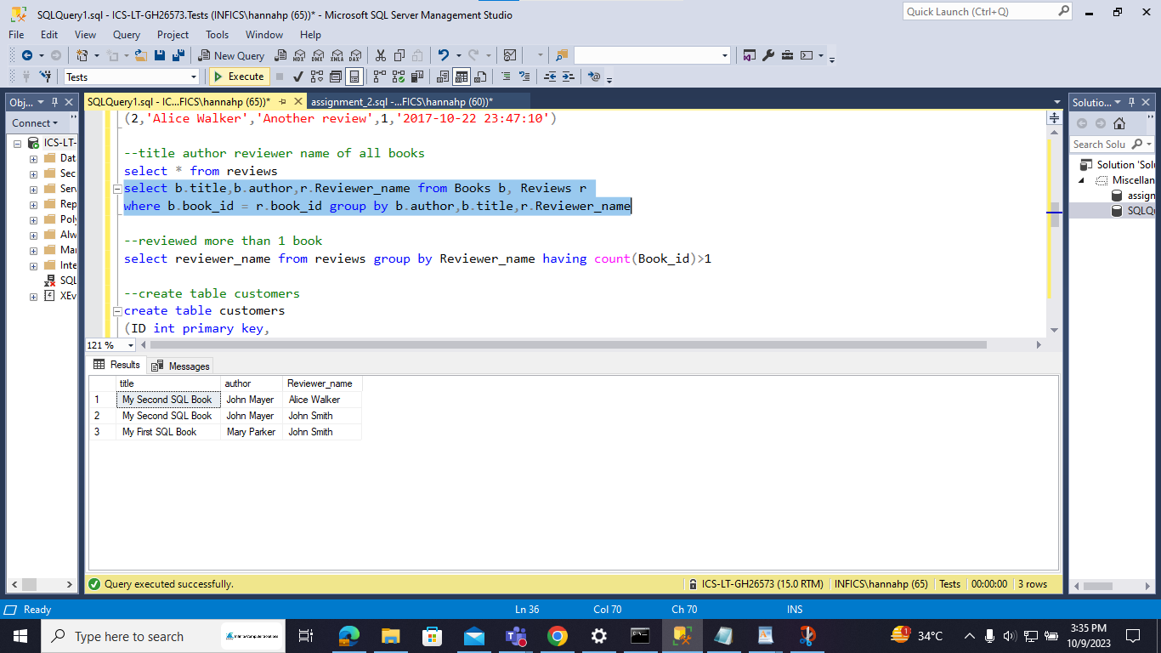

(Display the reviewer name who reviewed more than one book).

select reviewer_name from reviews group by Reviewer_name having count(Book_id)>1

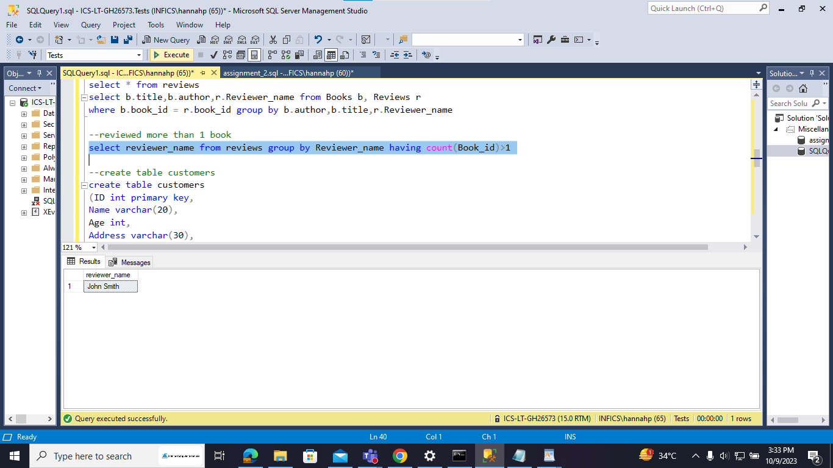

Question 2: Customers,Orders table

--create table customers

create table customers

(ID int primary key,

Name varchar(20),

Age int,

Address varchar(30),

Salary float)

--insert values to customers

insert into customers values

(1,'Ramesh',32,'Ahmedabad',2000.00),(2,'Khilan',25,'Delhi',1500.00),

(3,'Kaushik',23,'Kota',2000.00),(4,'Chaitali',25,'Mumbai',6500.00),

(5,'Hardik',27,'Bhopal',8500.00),(6,'Komal',22,'MP',4500.00),

(7,'Muffy',24,'Indore',10000.00)

(Display the Name for the customer from above customer table who live in same address which has character o anywhere in address)

select * from customers

select name from customers where Address like '%o%'

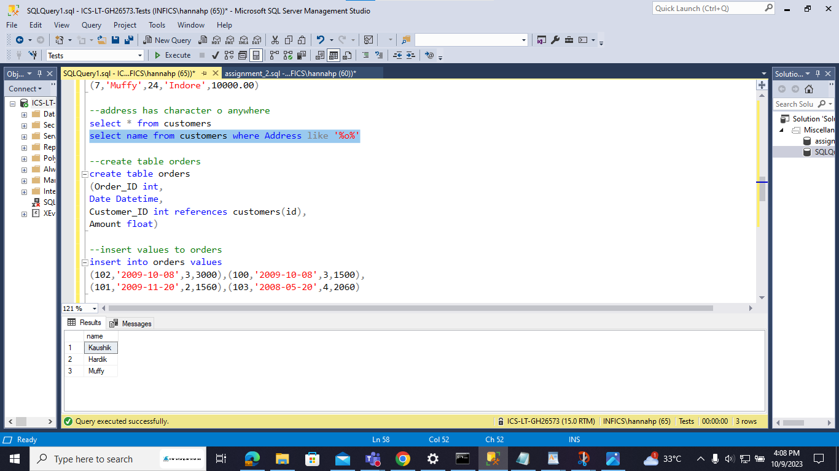

--create table orders

create table orders

(Order_ID int,

Date Datetime,

Customer_ID int references customers(id),

Amount float)

--insert values to orders

insert into orders values

(102,'2009-10-08',3,3000),(100,'2009-10-08',3,1500),

(101,'2009-11-20',2,1560),(103,'2008-05-20',4,2060)

(Write a query to display the Date,Total no of customer placed order on same Date )

select * from orders

select date,count(order_id) 'Total no. of customers' from orders group by date having count(order_id)>1

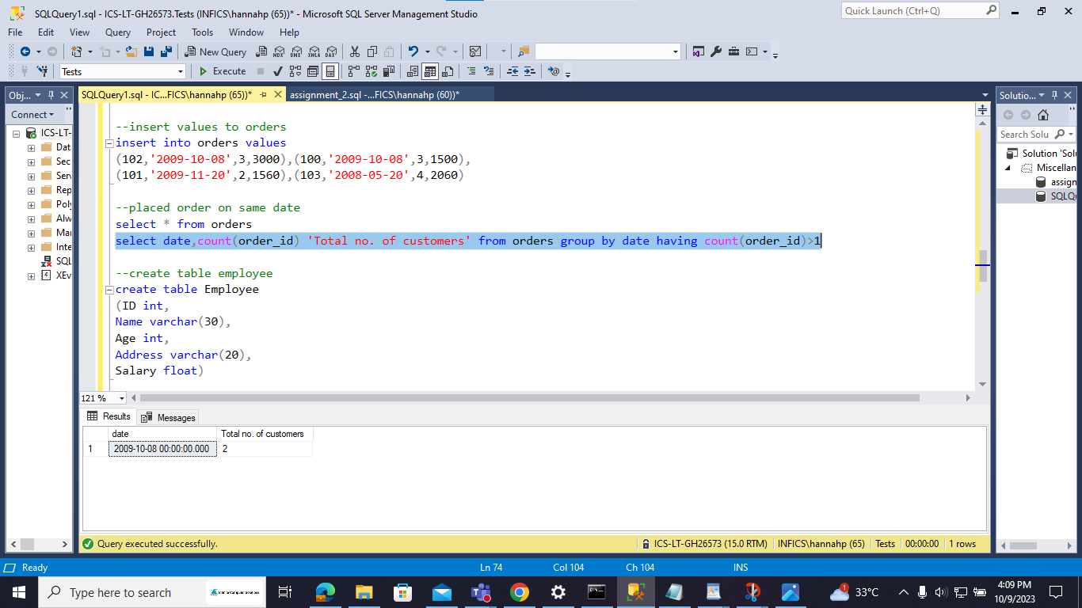

Question 3: Employees table

--create table employee

create table Employee

(ID int,

Name varchar(30),

Age int,

Address varchar(20),

Salary float)

--insert values to employees

insert into employee values

(1,'Ramesh',32,'Ahmedabad',2000.00),(2,'Khilan',25,'Delhi',1500.00),

(3,'Kaushik',23,'Kota',2000.00),(4,'Chaitali',25,'Mumbai',6500.00),

(5,'Hardik',27,'Bhopal',8500.00),(6,'Komal',22,'MP',null),

(7,'Muffy',24,'Indore',null)

(Display the Names of the Employee in lower case, whose salary is null )

select * from employee

select lower(name) 'Name in lower case' from employee where salary is null

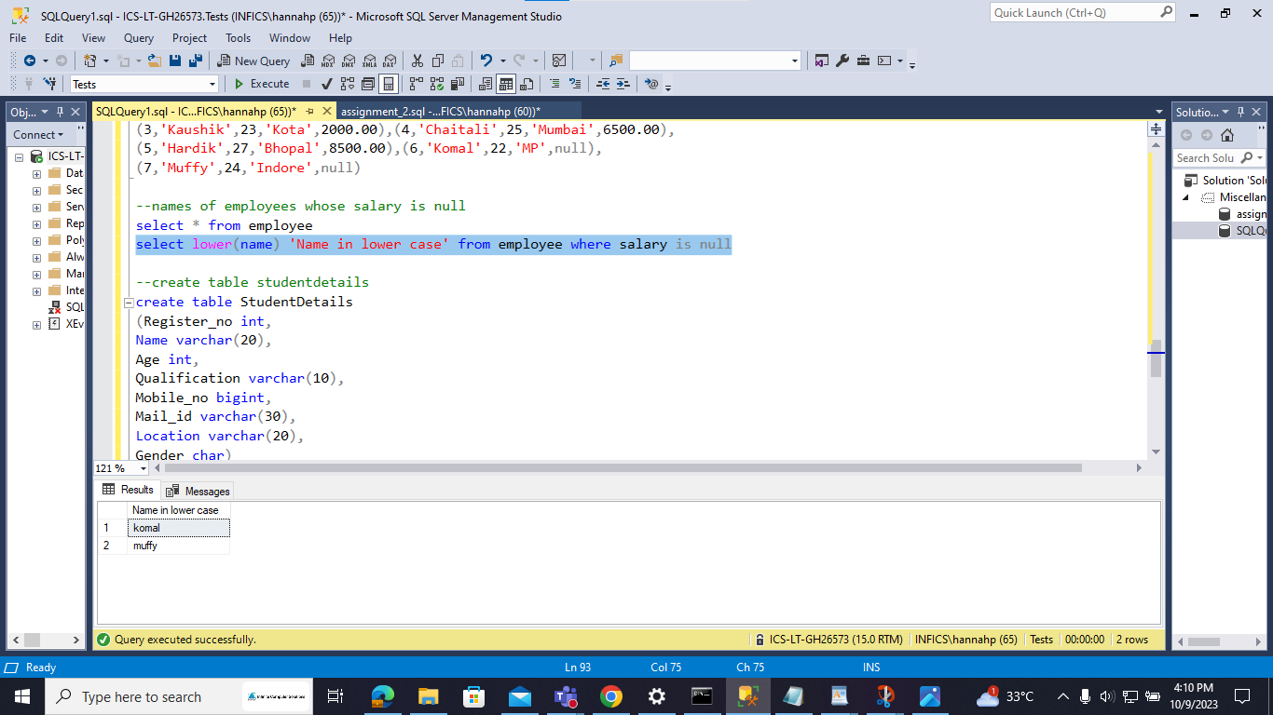

Question 4 : Student Details table

--create table studentdetails

create table StudentDetails

(Register_no int,

Name varchar(20),

Age int,

Qualification varchar(10),

Mobile_no bigint,

Mail_id varchar(30),

Location varchar(20),

Gender char)

--insert values to studentdetails

insert into StudentDetails values

(2,'Sai',22,'B.E',9952836777,'Sai@gmail.com','Chennai','M'),

(3,'Kumar',20,'BSC',7890125648,'Kumar@gmail.com','Madurai','M'),

(4,'Selvi',22,'B.Tech',8904567342,'Selvi@gmail.com','Selam','F'),

(5,'Nisha',25,'M.E',7834672310,'Nisha@gmail.com','Theni','F'),

(6,'SaiSaran',21,'B.A',7890345678,'Saran@gmail.com','Madurai','F'),

(7,'Tom',23,'BCA',8901234675,'Tom@gmail.com','Pune','M')

(Write a sql server query to display the Gender,Total no of male and female from the above

relation ) .

select * from StudentDetails

select gender,count(gender) 'Total' from StudentDetails group by gender

